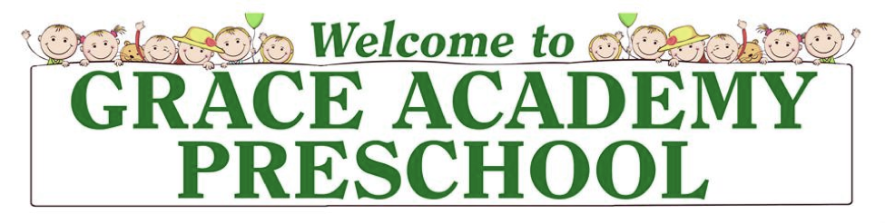

Enrollment
Packet
2018-2019

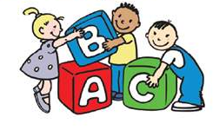

Updated February 6, 2018

Greetings!

We are glad you are considering being a part of our preschool. As parents, you are considering what kind of educational experience you want your child to have that will influence his or her life during these formative years. These decisions are important, as they will affect both your family as a whole and your child as an individual. We hope to work alongside you as we endeavor to provide an educational experience that will foster positive growth and development in your child.

Enclosed are the steps to re-enrolling your child with us. If you have any questions, please contact me by phone or by email as noted below. Thank you again for taking the time to consider Grace Academy.

Shane Lehman
Director
GraceAPreschool@gmail.com
717-755-6438

Vision Statement

Training children to love God, to love learning, and to be fully prepared for Kindergarten.

Mission Statement
Grace Academy Preschool exists to assist families with training their children by providing a Biblically-centered education wherein children are motivated to learn and grow.

We strive to create an environment where children can develop spiritually, intellectually, emotionally, physically, and socially. This begins by instilling in the children an understanding of God’s unconditional love for them. Instructional lessons will focus on such things as language skills, vocabulary building, cooperation, manners, physical exercise, decision-making, and the development of gross and fine-motor skills.

Refer to the Curriculum section for more detailed information.

CLASS INFORMATION
Classes: (9:00am-11:30am) Cost:
PK-3* – Tuesday & Thursday or $110/month
– Tuesday, Wednesday, & Thursday $125/month
PK-4* – Tuesday, Wednesday, & Thursday $125/month

Lunch Buddies Program options: (11:30-12:30)
- 1-Day (Wednesdays only) $20/month
- 3-days (T, W, Th) $30/month

*Children must be this age before September 1, 2018.
Child must be fully potty-trained to attend the PK-4 class and should mostly potty-trained to be enrolled in our PK-3 class.

Multi-Child Discount: 15% tuition discount for families enrolling multiple children.

5% Tuition Payment Discounts:
Parents may receive a 5% tuition discount if they pay the full tuition amount by Sept. 1.

“Lunch Buddies” Program – (11:30-12:30pm) – 2 options

Students will have lunch together as well as further times of recreation and instruction. Children need to bring a packed lunch. We offer a 1-day and a 3-day option. (see details above) If a child is withdrawn from the program without one month’s notice, a fee will be assessed in the amount of one month.

Tuition Payments
Tuition must be paid on or before the 1st of each month, beginning on September 1st. There will be a total of 9 payments, with the last payment being on May 1st. Tuition payments can be made by cash, personal check, or money order.

Staff
All of our teachers and aides are carefully selected and well qualified. They each have obtained their security clearances and are 1st Aid/CPR certified. Occasionally there may be volunteers working in the classes with the staff.

Parent – Teacher Relationship
We believe that the school is to be an extension of the home, not a substitute. Therefore, we seek to work closely with all parents to further enhance the child’s overall growth and development. If at any time you have questions or concerns, please feel free to contact the teacher or the director.
Facilities
The school is located in the Abundant Life Center. There are several primary classrooms that will be used for the preschool as well as other rooms available for use as needed. An outdoor playground area is located behind the facility.

Curriculum
Our classes fulfill all PA learning standards for early childhood. The following is a brief overview of curriculum for both classes:

~Hands on sensory experiences with the goal of encouraging creativity and readiness skills

~Emphasis on language development through a variety of interactive activities including singing, finger plays, and creative movement

~Theme-based individual and small group instruction, along with basic alphabet and number concepts

~Creative play and socialization with an emphasis on sharing, caring, and interaction

~Development of fine and gross motor skills with varied age-appropriate activities

Additional elements introduced in the PK-4 class include:

~Phonemic awareness, rhyming words, and opposites

~Mathematics introduced through calendar activities, as well as a variety of hands-on activities, and problem solving, with a strong emphasis on using manipulative tools

~Using the Handwriting Without Tears curriculum

~Creative movement through music and introductory sign language

Special Events
We will have special events throughout the school year including: a Fall Festival, Thanksgiving Feast, Christmas Program, an Easter Egg Hunt, Daddy’s Date Night, Mother’s Day Brunch, Grandparent’s Day, and many more. We will also go on a variety of field trips to fun locations including a fire station, orchard, zoo, and so much more! Families will have many opportunities to be involved. More specific details will be provided in the classroom newsletters.

Steps to Enrollment:

- Fill out the “Enrollment Form.” (Last page)

- Return the “Enrollment Form” along with your $35 non-refundable registration fee to Mr. Lehman or to Mrs. Lentz. Make all checks payable to Grace Academy Preschool. Our mailing address is:

Grace Academy Preschool
3930 Farm Drive
York, PA 17402

- Mark your calendars!

  - Monday, August 27, 2018 - Parent Orientation Night: meet the staff, meet other preschool families, receive important information. You will receive a reminder of this event by mail and/or email.

  - Tuesday, September 4, 2018 - First day of preschool for all students. This will also be the first day for those enrolled in the 3-day Lunch Buddies.

- For additional enrollment information or questions, please contact the Director, Mr. Lehman, by email: GraceApreschool@gmail.com, or by phone at 717-755-6438.

- After enrolling your child, you will receive an Acceptance Letter and a Parent Information Packet. Please complete those enclosed forms and return them to the preschool as soon as possible.

Enrollment Form – 2018-2019
(One form per child)
PERSONAL INFORMATION:

Child’s full name______________________________________ Age_______ Birthdate____________________
Gender: M/F Home Phone ________________________________
Home Address_______________________________________________________________________________________________
Primary Email ______________________________________________ School District ______________________________

Mother’s Name __________________________________________________ Mobile Phone_______________________
Place of Work____________________________________________________ Work phone_________________________

Father’s Name __________________________________________________ Mobile Phone_______________________
Place of Work____________________________________________________ Work phone_________________________

FAMILY INFORMATION:

Name(s) and age(s) of siblings______________________________________________________________________________
Are the parents living together? Yes _____ No _____
If no, with whom is the child living? ____________________________________________
Names of other persons residing in the home and relation to the child ________________________________________________________________________________________________________________
________________________________________________________________________________________________________________
Church presently attending __________________________________________________

OTHER INFORMATION:
Toilet training (check one) ____ In diapers/pull-ups ____ Needs to be reminded ____ Independent
Allergies (food, pet or other): _______________________________________________________________________________
How did you hear about our Preschool? ___________________________________________________________________

Additional comments: ___________________________________________________________________________________________
Lunch Buddies Enrollment Options:
(11:30am-12:30pm)

☐ 1-Day option (Wednesdays only) - $20/month

☐ 3-Day option (T, Wed., Th) - $30/month

Class Enrollment Options:

☐ PK-3 class (2 days -T/Th) - $110/month

☐ PK-3 class (3 days -T/W/Th) - $125/month

☐ PK-4 class (3 days – T/W/Th) - $125/month

Make checks payable to Grace Academy Preschool

